# Test Cases

For **n=3** (Number of Stairs)

Johan can take the following ways to reach Prayer Hall.

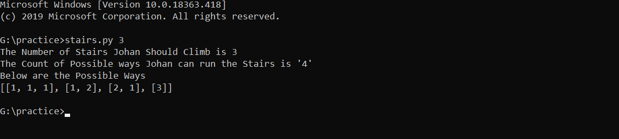

So, the count is: **4**

**The Possible Ways are:**

[1, 1, 1], [1, 2], [2, 1], [3]

-------------------------------------------------------------------------------------------------------------------------------

For **n=5** (Number of Stairs)

Johan can take the following ways to reach Prayer Hall.

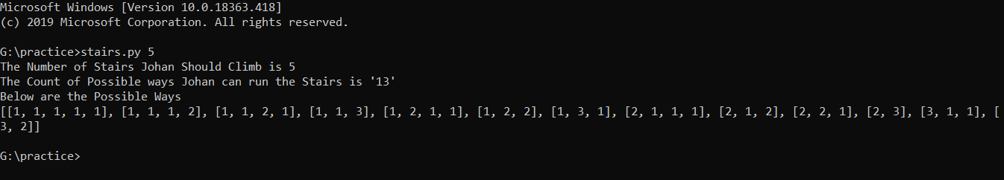

So, the count is: **13**

**The Possible Ways are:**

[1, 1, 1, 1, 1], [1, 1, 1, 2], [1, 1, 2, 1], [1, 1, 3], [1, 2, 1, 1], [1, 2, 2], [1, 3, 1], [2, 1, 1, 1], [2, 1, 2], [2, 2, 1], [2, 3], [3, 1, 1], [3, 2]

For **n=10** (Number of Stairs)

Johan can take the following ways to reach Prayer Hall.

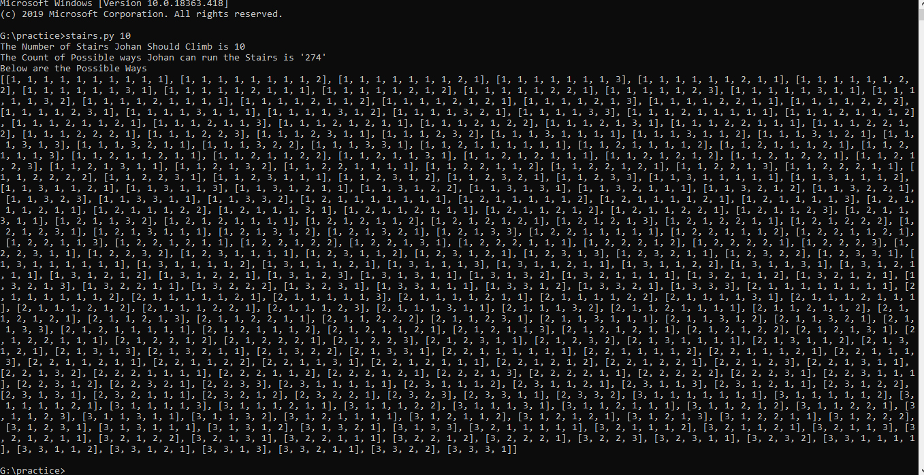

So, the count is: **274**

**The Possible Ways are:**

[1, 1, 1, 1, 1, 1, 1, 1, 1, 1], [1, 1, 1, 1, 1, 1, 1, 1, 2], [1, 1, 1, 1, 1, 1, 1, 2, 1], [1, 1, 1, 1, 1, 1, 1, 3], [1, 1, 1, 1, 1, 1, 2, 1, 1], [1, 1, 1, 1, 1, 1, 2, 2], [1, 1, 1, 1, 1, 1, 3, 1], [1, 1, 1, 1, 1, 2, 1, 1, 1], [1, 1, 1, 1, 1, 2, 1, 2], [1, 1, 1, 1, 1, 2, 2, 1], [1, 1, 1, 1, 1, 2, 3], [1, 1, 1, 1, 1, 3, 1, 1], [1, 1, 1, 1, 1, 3, 2], [1, 1, 1, 1, 2, 1, 1, 1, 1], [1, 1, 1, 1, 2, 1, 1, 2], [1, 1, 1, 1, 2, 1, 2, 1], [1, 1, 1, 1, 2, 1, 3], [1, 1, 1, 1, 2, 2, 1, 1], [1, 1, 1, 1, 2, 2, 2], [1, 1, 1, 1, 2, 3, 1], [1, 1, 1, 1, 3, 1, 1, 1], [1, 1, 1, 1, 3, 1, 2], [1, 1, 1, 1, 3, 2, 1], [1, 1, 1, 1, 3, 3], [1, 1, 1, 2, 1, 1, 1, 1, 1], [1, 1, 1, 2, 1, 1, 1, 2], [1, 1, 1, 2, 1, 1, 2, 1], [1, 1, 1, 2, 1, 1, 3], [1, 1, 1, 2, 1, 2, 1, 1], [1, 1, 1, 2, 1, 2, 2], [1, 1, 1, 2, 1, 3, 1], [1, 1, 1, 2, 2, 1, 1, 1], [1, 1, 1, 2, 2, 1, 2], [1, 1, 1, 2, 2, 2, 1], [1, 1, 1, 2, 2, 3], [1, 1, 1, 2, 3, 1, 1], [1, 1, 1, 2, 3, 2], [1, 1, 1, 3, 1, 1, 1, 1], [1, 1, 1, 3, 1, 1, 2], [1, 1, 1, 3, 1, 2, 1], [1, 1, 1, 3, 1, 3], [1, 1, 1, 3, 2, 1, 1], [1, 1, 1, 3, 2, 2], [1, 1, 1, 3, 3, 1], [1, 1, 2, 1, 1, 1, 1, 1, 1], [1, 1, 2, 1, 1, 1, 1, 2], [1, 1, 2, 1, 1, 1, 2, 1], [1, 1, 2, 1, 1, 1, 3], [1, 1, 2, 1, 1, 2, 1, 1], [1, 1, 2, 1, 1, 2, 2], [1, 1, 2, 1, 1, 3, 1], [1, 1, 2, 1, 2, 1, 1, 1], [1, 1, 2, 1, 2, 1, 2], [1, 1, 2, 1, 2, 2, 1], [1, 1, 2, 1, 2, 3], [1, 1, 2, 1, 3, 1, 1], [1, 1, 2, 1, 3, 2], [1, 1, 2, 2, 1, 1, 1, 1], [1, 1, 2, 2, 1, 1, 2], [1, 1, 2, 2, 1, 2, 1], [1, 1, 2, 2, 1, 3], [1, 1, 2, 2, 2, 1, 1], [1, 1, 2, 2, 2, 2], [1, 1, 2, 2, 3, 1], [1, 1, 2, 3, 1, 1, 1], [1, 1, 2, 3, 1, 2], [1, 1, 2, 3, 2, 1], [1, 1, 2, 3, 3], [1, 1, 3, 1, 1, 1, 1, 1], [1, 1, 3, 1, 1, 1, 2], [1, 1, 3, 1, 1, 2, 1], [1, 1, 3, 1, 1, 3], [1, 1, 3, 1, 2, 1, 1], [1, 1, 3, 1, 2, 2], [1, 1, 3, 1, 3, 1], [1, 1, 3, 2, 1, 1, 1], [1, 1, 3, 2, 1, 2], [1, 1, 3, 2, 2, 1], [1, 1, 3, 2, 3], [1, 1, 3, 3, 1, 1], [1, 1, 3, 3, 2], [1, 2, 1, 1, 1, 1, 1, 1, 1], [1, 2, 1, 1, 1, 1, 1, 2], [1, 2, 1, 1, 1, 1, 2, 1], [1, 2, 1, 1, 1, 1, 3], [1, 2, 1, 1, 1, 2, 1, 1], [1, 2, 1, 1, 1, 2, 2], [1, 2, 1, 1, 1, 3, 1], [1, 2, 1, 1, 2, 1, 1, 1], [1, 2, 1, 1, 2, 1, 2], [1, 2, 1, 1, 2, 2, 1], [1, 2, 1, 1, 2, 3], [1, 2, 1, 1, 3, 1, 1], [1, 2, 1, 1, 3, 2], [1, 2, 1, 2, 1, 1, 1, 1], [1, 2, 1, 2, 1, 1, 2], [1, 2, 1, 2, 1, 2, 1], [1, 2, 1, 2, 1, 3], [1, 2, 1, 2, 2, 1, 1], [1, 2, 1, 2, 2, 2], [1, 2, 1, 2, 3, 1], [1, 2, 1, 3, 1, 1, 1], [1, 2, 1, 3, 1, 2], [1, 2, 1, 3, 2, 1], [1, 2, 1, 3, 3], [1, 2, 2, 1, 1, 1, 1, 1], [1, 2, 2, 1, 1, 1, 2], [1, 2, 2, 1, 1, 2, 1], [1, 2, 2, 1, 1, 3], [1, 2, 2, 1, 2, 1, 1], [1, 2, 2, 1, 2, 2], [1, 2, 2, 1, 3, 1], [1, 2, 2, 2, 1, 1, 1], [1, 2, 2, 2, 1, 2], [1, 2, 2, 2, 2, 1], [1, 2, 2, 2, 3], [1, 2, 2, 3, 1, 1], [1, 2, 2, 3, 2], [1, 2, 3, 1, 1, 1, 1], [1, 2, 3, 1, 1, 2], [1, 2, 3, 1, 2, 1], [1, 2, 3, 1, 3], [1, 2, 3, 2, 1, 1], [1, 2, 3, 2, 2], [1, 2, 3, 3, 1], [1, 3, 1, 1, 1, 1, 1, 1], [1, 3, 1, 1, 1, 1, 2], [1, 3, 1, 1, 1, 2, 1], [1, 3, 1, 1, 1, 3], [1, 3, 1, 1, 2, 1, 1], [1, 3, 1, 1, 2, 2], [1, 3, 1, 1, 3, 1], [1, 3, 1, 2, 1, 1, 1], [1, 3, 1, 2, 1, 2], [1, 3, 1, 2, 2, 1], [1, 3, 1, 2, 3], [1, 3, 1, 3, 1, 1], [1, 3, 1, 3, 2], [1, 3, 2, 1, 1, 1, 1], [1, 3, 2, 1, 1, 2], [1, 3, 2, 1, 2, 1], [1, 3, 2, 1, 3], [1, 3, 2, 2, 1, 1], [1, 3, 2, 2, 2], [1, 3, 2, 3, 1], [1, 3, 3, 1, 1, 1], [1, 3, 3, 1, 2], [1, 3, 3, 2, 1], [1, 3, 3, 3], [2, 1, 1, 1, 1, 1, 1, 1, 1], [2, 1, 1, 1, 1, 1, 1, 2], [2, 1, 1, 1, 1, 1, 2, 1], [2, 1, 1, 1, 1, 1, 3], [2, 1, 1, 1, 1, 2, 1, 1], [2, 1, 1, 1, 1, 2, 2], [2, 1, 1, 1, 1, 3, 1], [2, 1, 1, 1, 2, 1, 1, 1], [2, 1, 1, 1, 2, 1, 2], [2, 1, 1, 1, 2, 2, 1], [2, 1, 1, 1, 2, 3], [2, 1, 1, 1, 3, 1, 1], [2, 1, 1, 1, 3, 2], [2, 1, 1, 2, 1, 1, 1, 1], [2, 1, 1, 2, 1, 1, 2], [2, 1, 1, 2, 1, 2, 1], [2, 1, 1, 2, 1, 3], [2, 1, 1, 2, 2, 1, 1], [2, 1, 1, 2, 2, 2], [2, 1, 1, 2, 3, 1], [2, 1, 1, 3, 1, 1, 1], [2, 1, 1, 3, 1, 2], [2, 1, 1, 3, 2, 1], [2, 1, 1, 3, 3], [2, 1, 2, 1, 1, 1, 1, 1], [2, 1, 2, 1, 1, 1, 2], [2, 1, 2, 1, 1, 2, 1], [2, 1, 2, 1, 1, 3], [2, 1, 2, 1, 2, 1, 1], [2, 1, 2, 1, 2, 2], [2, 1, 2, 1, 3, 1], [2, 1, 2, 2, 1, 1, 1], [2, 1, 2, 2, 1, 2], [2, 1, 2, 2, 2, 1], [2, 1, 2, 2, 3], [2, 1, 2, 3, 1, 1], [2, 1, 2, 3, 2], [2, 1, 3, 1, 1, 1, 1], [2, 1, 3, 1, 1, 2], [2, 1, 3, 1, 2, 1], [2, 1, 3, 1, 3], [2, 1, 3, 2, 1, 1], [2, 1, 3, 2, 2], [2, 1, 3, 3, 1], [2, 2, 1, 1, 1, 1, 1, 1], [2, 2, 1, 1, 1, 1, 2], [2, 2, 1, 1, 1, 2, 1], [2, 2, 1, 1, 1, 3], [2, 2, 1, 1, 2, 1, 1], [2, 2, 1, 1, 2, 2], [2, 2, 1, 1, 3, 1], [2, 2, 1, 2, 1, 1, 1], [2, 2, 1, 2, 1, 2], [2, 2, 1, 2, 2, 1], [2, 2, 1, 2, 3], [2, 2, 1, 3, 1, 1], [2, 2, 1, 3, 2], [2, 2, 2, 1, 1, 1, 1], [2, 2, 2, 1, 1, 2], [2, 2, 2, 1, 2, 1], [2, 2, 2, 1, 3], [2, 2, 2, 2, 1, 1], [2, 2, 2, 2, 2], [2, 2, 2, 3, 1], [2, 2, 3, 1, 1, 1], [2, 2, 3, 1, 2], [2, 2, 3, 2, 1], [2, 2, 3, 3], [2, 3, 1, 1, 1, 1, 1], [2, 3, 1, 1, 1, 2], [2, 3, 1, 1, 2, 1], [2, 3, 1, 1, 3], [2, 3, 1, 2, 1, 1], [2, 3, 1, 2, 2], [2, 3, 1, 3, 1], [2, 3, 2, 1, 1, 1], [2, 3, 2, 1, 2], [2, 3, 2, 2, 1], [2, 3, 2, 3], [2, 3, 3, 1, 1], [2, 3, 3, 2], [3, 1, 1, 1, 1, 1, 1, 1], [3, 1, 1, 1, 1, 1, 2], [3, 1, 1, 1, 1, 2, 1], [3, 1, 1, 1, 1, 3], [3, 1, 1, 1, 2, 1, 1], [3, 1, 1, 1, 2, 2], [3, 1, 1, 1, 3, 1], [3, 1, 1, 2, 1, 1, 1], [3, 1, 1, 2, 1, 2], [3, 1, 1, 2, 2, 1], [3, 1, 1, 2, 3], [3, 1, 1, 3, 1, 1], [3, 1, 1, 3, 2], [3, 1, 2, 1, 1, 1, 1], [3, 1, 2, 1, 1, 2], [3, 1, 2, 1, 2, 1], [3, 1, 2, 1, 3], [3, 1, 2, 2, 1, 1], [3, 1, 2, 2, 2], [3, 1, 2, 3, 1], [3, 1, 3, 1, 1, 1], [3, 1, 3, 1, 2], [3, 1, 3, 2, 1], [3, 1, 3, 3], [3, 2, 1, 1, 1, 1, 1], [3, 2, 1, 1, 1, 2], [3, 2, 1, 1, 2, 1], [3, 2, 1, 1, 3], [3, 2, 1, 2, 1, 1], [3, 2, 1, 2, 2], [3, 2, 1, 3, 1], [3, 2, 2, 1, 1, 1], [3, 2, 2, 1, 2], [3, 2, 2, 2, 1], [3, 2, 2, 3], [3, 2, 3, 1, 1], [3, 2, 3, 2], [3, 3, 1, 1, 1, 1], [3, 3, 1, 1, 2], [3, 3, 1, 2, 1], [3, 3, 1, 3], [3, 3, 2, 1, 1], [3, 3, 2, 2], [3, 3, 3, 1]]